1.8 Hyperbolic Trigonometric Functions

Motivation: The trigonometric functions work well when we are trying to do trigonometry on a plane (intuitively a plane is a flat, infinite two dimensional object).

However, it doesn’t always make sense to do trigonometry on the plane. For example, the earth is roughly a sphere and trigonometry on a sphere is different than trigonometry on a plane. Another example where trigonometry will be different is if we are on a hyperbolic plane.

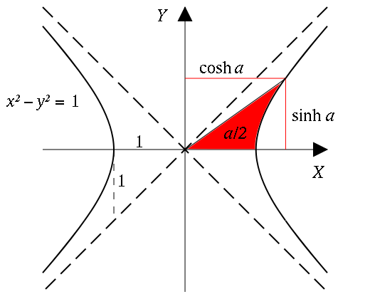

This leads to the following definitions.
Definitions: We define six hyperbolic trig functions.
Pronounced "sinch”

Pronounced "cosh”

Example 1: Evaluate each of the following using the definition.

Graphs of hyperbolic functions:

Theorem: We have the following identities for all real x that are in the domain of the functions involved in each identity:

Example 2: Show that .

Example 3: Find and .

Theorem: We have the following derivatives for our six hyperbolic trig. functions.

Applications
Hyperbolic functions arise when a homogeneous cable is suspended between two points.

Catenary Curve  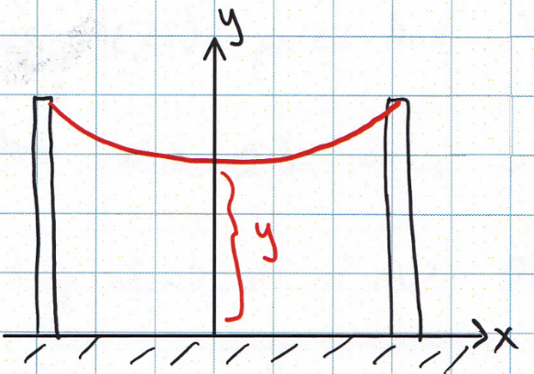 | (where a and c are constants driven by the type of cable and the distance between the poles.)

Example 4: Suppose a cable is attached between two poles which stand 30ft apart and can be modelled by the function . Determine the exact length of the cable from .

Example 5: Consider the region bounded by the curves & from .

- Determine the exact value of the area of this region.

- Set up, but do not evaluate, and integral which represents the volume when this region is revolved around the y-axis.

- Suppose you rotate the curve on about the x-axis and attempt to determine the surface area of the resulting solid. Why does the integral not represent this surface area?

